DESIGN AND ANALYSIS OF ALGORITHMS(LAB-5)

Name: D. Chetan Kumar
Roll no: CH.SC.U4CSE24209

1.Merge Sort
Code:
#include <stdio.h>

void merge(int arr[], int left, int mid, int right)
{
int i, j, k;
int n1 = mid - left + 1;
int n2 = right - mid;

int L[n1], R[n2];

for (i = 0; i < n1; i++)
L[i] = arr[left + i];

for (j = 0; j < n2; j++)
R[j] = arr[mid + 1 + j];

i = 0;
j = 0;
k = left;

while (i < n1 && j < n2)
{
if (L[i] <= R[j])
arr[k++] = L[i++];
else
arr[k++] = R[j++];
}

while (i < n1)
arr[k++] = L[i++];

while (j < n2)
arr[k++] = R[j++];
}

void mergeSort(int arr[], int left, int right)
{
if (left < right)
{
int mid = (left + right) / 2;
mergeSort(arr, left, mid);
mergeSort(arr, mid + 1, right);
merge(arr, left, mid, right);
}
}
int main()
{
int arr[100], n, i;
printf("Enter number of elements: ");
scanf("%d", &n);
printf("Enter array elements:\n");
for (i = 0; i < n; i++)
scanf("%d", &arr[i]);
mergeSort(arr, 0, n - 1);
printf("Sorted array:\n");
for (i = 0; i < n; i++)
printf("%d ", arr[i]);
return 0;
}
Output:
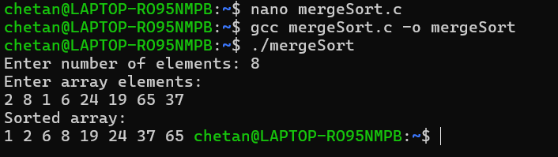
Complexity analysis
- Best Case: O(n log n), When the array is already sorted or nearly sorted.
- Average Case: O(n log n), When the array is randomly ordered.
- Worst Case: O(n log n), When the array is sorted in reverse order.

2.Quick Sort
Code:
#include <stdio.h>

void swap(int *a, int *b)
{
int temp = *a;
*a = *b;
*b = temp;
}
int partition(int arr[], int low, int high)
{
int pivot = arr[high];
int i = low - 1;
for (int j = low; j < high; j++)
{
if (arr[j] < pivot)
{
i++;
swap(&arr[i], &arr[j]);
}
}
swap(&arr[i + 1], &arr[high]);
return i + 1;
}
void quickSort(int arr[], int low, int high)
{
if (low < high)
{
int pi = partition(arr, low, high);
quickSort(arr, low, pi - 1);
quickSort(arr, pi + 1, high);
}
}
int main()
{
int arr[100], n;
printf("Enter number of elements: ");
scanf("%d", &n);
printf("Enter array elements:\n");
for (int i = 0; i < n; i++)
scanf("%d", &arr[i]);
quickSort(arr, 0, n - 1);
printf("Sorted array:\n");
for (int i = 0; i < n; i++)
printf("%d ", arr[i]);
return 0;
}
Output:
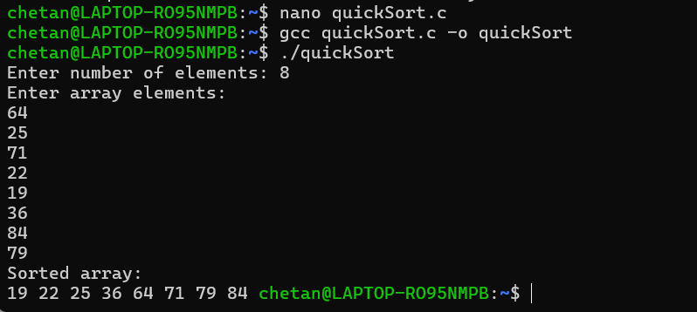
Complexity Analysis of Bubble Sort

Best case: O(n)
Average case: O(n^2)
Worst case: O(n^2)

3.Binary Search Tree(BST)
Code:
#include <stdio.h>
#include <stdlib.h>

/* Structure for BST Node */
struct Node
{
int key;
struct Node *left, *right;
};

/* Create a new node */
struct Node *newNodeCreate(int value)
{
struct Node *temp = (struct Node *)malloc(sizeof(struct Node));
temp->key = value;
temp->left = temp->right = NULL;
return temp;
}

/* Search a node in BST */
struct Node *searchNode(struct Node *root, int target)
{
if (root == NULL || root->key == target)
return root;

if (root->key < target)
return searchNode(root->right, target);

return searchNode(root->left, target);
}

/* Insert a node in BST */
struct Node *insertNode(struct Node *node, int value)
{
if (node == NULL)
return newNodeCreate(value);

if (value < node->key)
node->left = insertNode(node->left, value);
else if (value > node->key)
node->right = insertNode(node->right, value);

return node;
}

/* Postorder traversal */
void postOrder(struct Node *root)
{
if (root != NULL)
{
postOrder(root->left);
postOrder(root->right);
printf("%d ", root->key);
}
}

/* Inorder traversal */
void inOrder(struct Node *root)
{
if (root != NULL)
{
inOrder(root->left);
printf("%d ", root->key);
inOrder(root->right);
}
}

/* Preorder traversal */
void preOrder(struct Node *root)
{
if (root != NULL)
{
printf("%d ", root->key);
preOrder(root->left);
preOrder(root->right);
}
}

/* Find minimum value node */
struct Node *findMin(struct Node *root)
{
if (root == NULL)
return NULL;
else if (root->left != NULL)
return findMin(root->left);
return root;
}

/* Delete a node from BST */
struct Node *delete(struct Node *root, int x)
{
if (root == NULL)
return NULL;

if (x > root->key)
root->right = delete(root->right, x);
else if (x < root->key)
root->left = delete(root->left, x);
else
{
/* No child */
if (root->left == NULL && root->right == NULL)
{
free(root);
return NULL;
}
/* One child */
else if (root->left == NULL || root->right == NULL)
{
struct Node *temp;
if (root->left == NULL)
temp = root->right;
else
temp = root->left;

free(root);
return temp;
}
/* Two children */
else
{
struct Node *temp = findMin(root->right);
root->key = temp->key;
root->right = delete(root->right, temp->key);
}
}
return root;
}

/* Main function */
int main()
{
struct Node *root = NULL;

root = insertNode(root, 50);
insertNode(root, 30);
insertNode(root, 20);
insertNode(root, 40);
insertNode(root, 70);
insertNode(root, 60);
insertNode(root, 80);

if (searchNode(root, 60) != NULL)
printf("60 found\n");
else
printf("60 not found\n");

printf("Postorder: ");
postOrder(root);
printf("\n");

printf("Preorder: ");
preOrder(root);
printf("\n");

printf("Inorder: ");
inOrder(root);
printf("\n");

return 0;
}
Output:
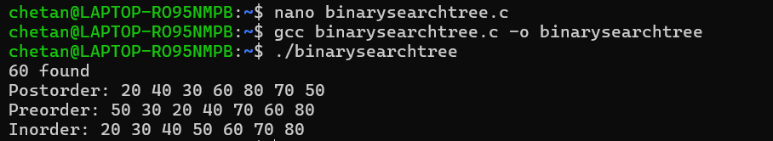

- All nodes in the left subtree of a node contain values strictly less than the node’s value.
- All nodes in the right subtree of a node contain values strictly greater than the node’s value.

